CUTTING PROCESS

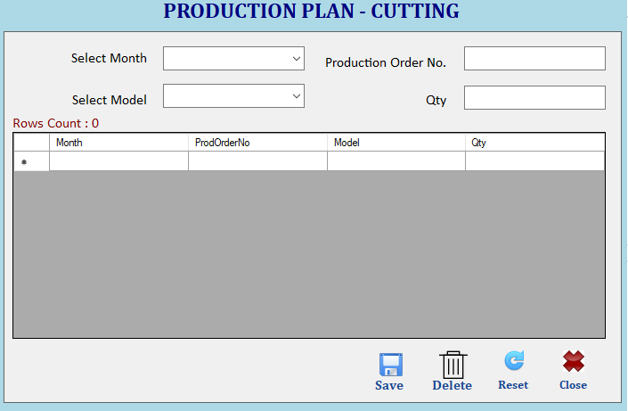

User will create production plan by selecting Month, Model & entering production Order No. & Quantity.
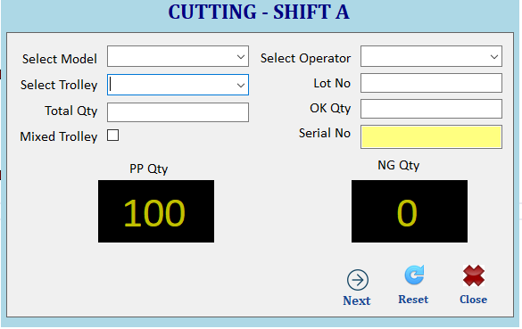
User will select Model, Operator & enter necessary details with Troley total qty & ok qty. Against that NG qty will pop up automatically.
If NG Qty is greater than 0 then
By pressing Next button user will move on to material defect screen or trolley card print will come.
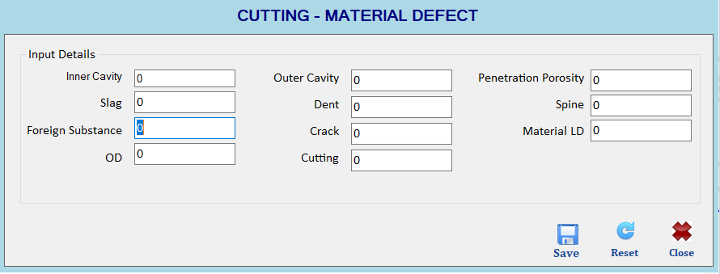
User Will enter defect parameters and save it to database. At same time mentioned trolly card will be printed
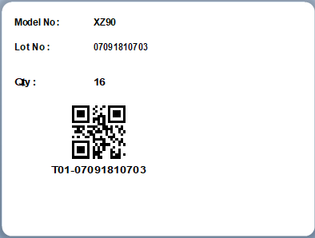

QA PROCESS
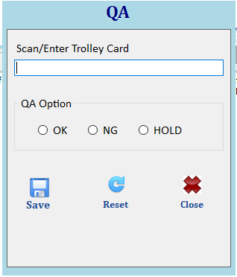
User will scan Trolly card & will give QA input for trolly
ok trolly will be eligible for further processes
HOLD trolly will not be eligible for further processes untill any final decision will be made
once Trolly will be marked NG in the system and will not be eligible for further processes
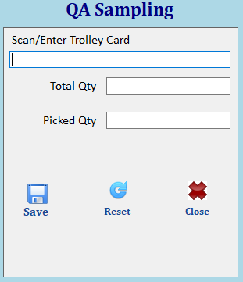
Any suspicious trolly, QA can pick material for sample, by scanning trolly card trolly qty will be displayed.
By entering picked qty userwill pick the material & that material will be marked as NG
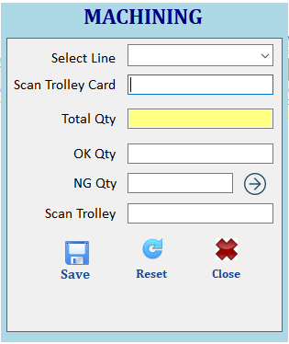
User Will select Line No And Scan the trolley card which will show total qty automatically then user will input ok qty and ng qty if ng qty is greater than 0 then user will click on  button to input defect
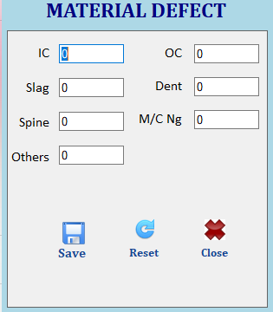
Then user will scan new trolley and click on save button. If qty validate successful then new trolley card will print.
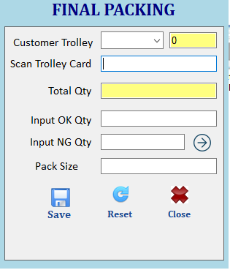
User Will select customer trolley, if there is any qty in the trolley already then application will show the qty automatically.
User will scan the trolley card which will show the total qty and pack size of customer trolley.
User will input ok qty, Ng Qty. If Ng Qty > 0 then user has to input defect qty.
When user will click on save button if qty is completed then it will generate trolley card.
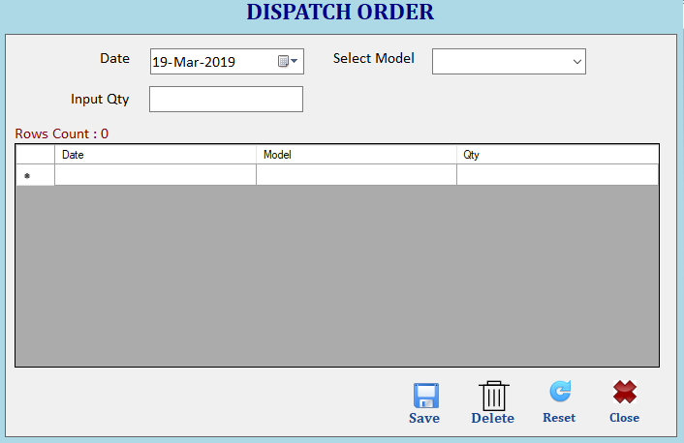
User will select model and input qty that need to be dispatched Current Day.
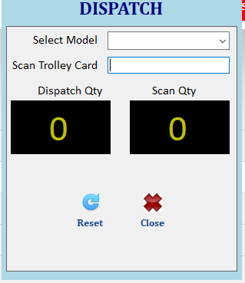
User will select model which will show the today’s dispatch qty that need to be dispatched then user will scan trolley card and it will increase the scan qty.
When Dispatch qty and scan qty will be same then application will show message dispatch complete.

